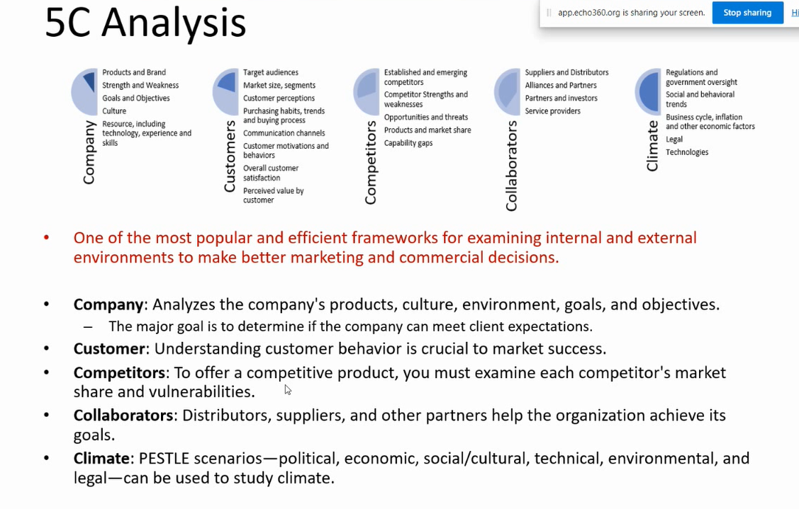

**5C Analysis**

**COMPANY**

**Strengths**

* The company focuses exclusively on deepfake detection and awareness
* The company is developing to specialize in video, image, voice recordings, and text
* The company’s big goal is real-time detection, giving our clients more effective and timely detection.
* With a focus only on protecting businesses and the public from deep fakes, the company can be trusted by all groups without bias

**Weaknesses**

* The company is new and therefore unproven, which may make it more difficult to attract customers.
* With new unproven technologies, it will take longer to develop software because there is less previous work to build from.
* As a new company, the resources available will be initially lacking, and highly dependent on finding stakeholder support for success.

**CUSTOMERS**

* Our company aims to target customers on social media platforms who want to ensure the information they are reviewing is authentic and not created with generative tools
  + Target news readers/watchers, content creators and art/media enthusiasts
  + Allow target audience to taylor their feeds and automatically remove AI content
* Market size could be a large user base considering how ~5 billion use social media daily.
* Many potential customers have negative perceptions and issues with AI content already
  + Market need is already there, not trying to create a new one
  + Targeting specific audiences who either want news or art to be analyzed
  + These groups will be perceive our tool as valuable for their daily life
* Many online users are already comfortable with and understand subscription services
  + Purchasing habits include customers desiring smaller payments monthly
  + Free model to draw users in
  + Offer exclusive benefits and most up-to-date AI detection model with paid
* Communicate with customers & promote our product itself through social media
  + Partnerships with Google (YouTube) or X to integrate or promote our product on their websites
* Aim on customer satisfaction & customization with a focus on how our detect model interacts with their day to day use of social media

**COMPETITORS**

* Previously established (HW2) were three key competitors
  + Microsoft Video Authenticator
    - Has the advantage of Microsoft’s resources
    - Works by detecting subtle fades or grayscale elements imperceptible to the human eye
    - Is focused mainly on political content
    - Is not focused on access to the public
  + Google DeepFake Protection
    - Has the advantage of Google’s resources
    - Large training database
    - Is mainly research focused
    - Not designed as a sellable commercial solution (at the present time)
  + Facebook DeepFake Protection
    - Has the Advantage of Meta’s resources
    - Meta also creates AI Image generators (good self training)
    - Focused on facial alterations, though constantly improving
    - Is designed for the public and companies
    - Likely the toughest competitor due to their similar goals, but limited in detention capabilities (at the present time)

**COLLABORATORS**

* Potential collaboration with stakeholders or other AI detection companies can benefit the company with additional resources and visibility
* Google as a collaborator:
  + A good option for collaboration as they are currently research focused and not selling to the consumer market as much (at the present time)
  + Would benefit the company with increased resources (large databases, potential monetary help)
  + Would lead to increased visibility due to Google’s large popularity around the globe and across industries
* Stakeholders:
  + Investors interested in deepfake protection can benefit the company with increased resources to develop the product
  + Potential partnership with commercial clients early on can benefit the company with monetary investment and loyalty to the brand when complete
    - Commercial clients could include large companies involved with media such as media organizations, social media apps, or investigation firms
    - Incentive for these stakeholders would include better fit to their needs, investment, and earlier access to DeepFake detection.

**CLIMATE**

* Social media & reality is more divided than ever politically, so ensuring customers with 100% confidence about what they see online is key to our company’s goal
* AI currently isn’t difficult to detect (it is pretty visually obvious sometimes) but as AI technology improves, it will be harder and harder to differentiate.
  + Our company aims to stay on top of and improve on combating the spread of manipulative AI generative content as the generation improves itself
* Targeting social media to sell our product is efficient as many current world issues with using AI stem from dissatisfaction with our it potentially affects our daily lives online
* Our company would need to stay up to date on government regulations and policies involving AI as they are created
* Our service model will need to be continuously updated as the technological climate changes, with including combatting potentially unseen uses of AI that could be seen as harmful in the future